Mathematical Model:

Parameters –

i ɛ 1,2 (I is index for Location 1 and Location 2)

j ɛ 1,2,3….12 (j is index for 12 events)

Cij : Unit cost to deliver a packet of balloon from location I to event j.

Pi : Production cost at location i.

Dj : Demand at event j.

M : Maximum number of packets of balloons that can be delivered from each location to each event; M = 1000

Zi : Production capacity at location i.

Decision Variable –

Xij : Number of packets of balloons to be delivered from location i to event j.

Objective –

Minimize the total cost = $\sum_{j=1}^{12}{\sum_{i=1}^{2}{\left(Xij*Cij\right) + \sum_{j=1}^{12}{\sum_{i=1}^{2}{(Xij*Pi)}}}}$

Constraints –

$1 ) Xij≥0$ (Non-Negative Constraint)

$2) \sum_{j=1}^{12}{Xij≤Zi; for i ∈\left\{1,2\right\}}$ (Production Capacity Constraint)

$3) \sum_{i=1}^{2}{Xij≥Dj for j ∈\{1,2,3…..12\}}$ (Demand Constraint)

$4) Xij≤M$ (Location to Event Supply Constraint)

**Optimal Solution:**

As we can see from the image attached below that the minimized cost comes out to be $955,650. Also the number of packets of balloons to be delivered from each location to each event is calculated by the solver keeping in mind the demand of each event and production capacity of each location.

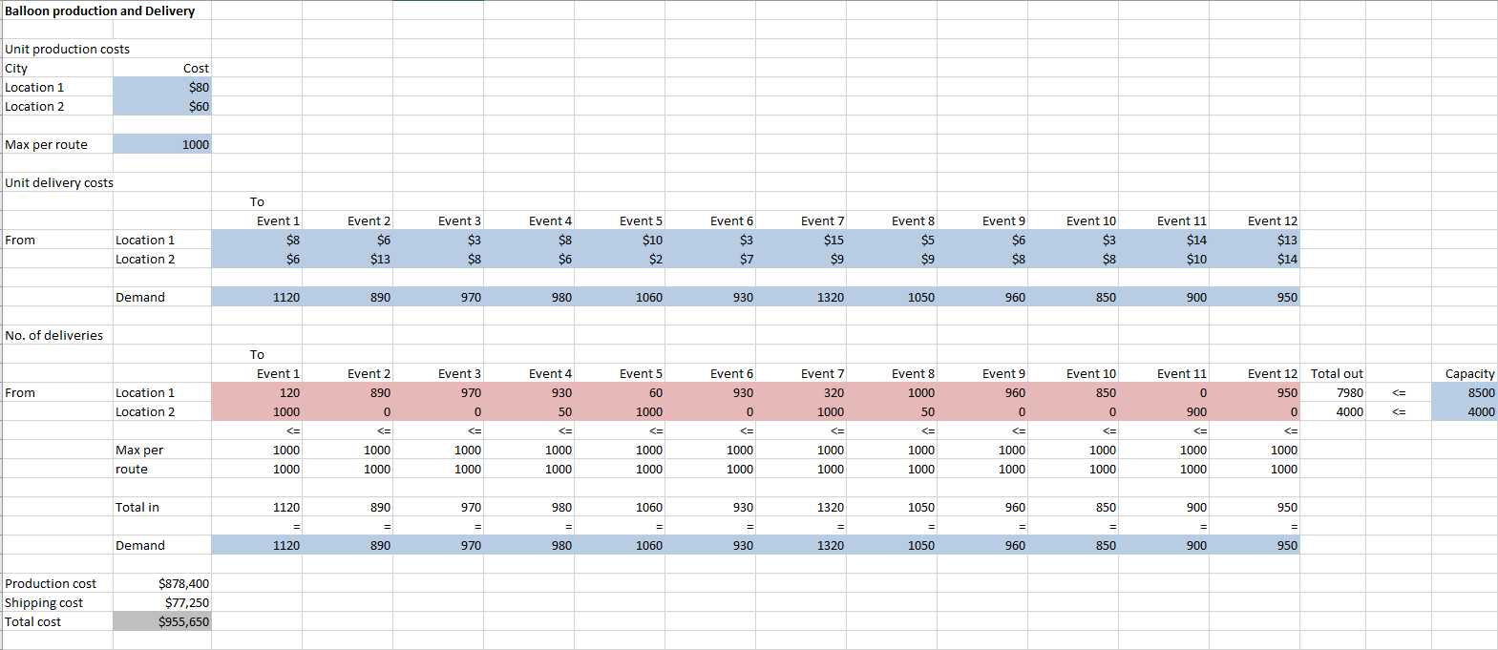

**Sensitivity Analysis:**

The analysis made from the sensitivity report obtained is as follows:

1. The reduced cost column tells us that if we deliver 1 packet of balloon from a particular location to a particular event then how much the total profit will increase or decrease.
2. Show Price column tell us how much change will be incurred in the profit if the value in the constraint R.H side column increases by a unit.

